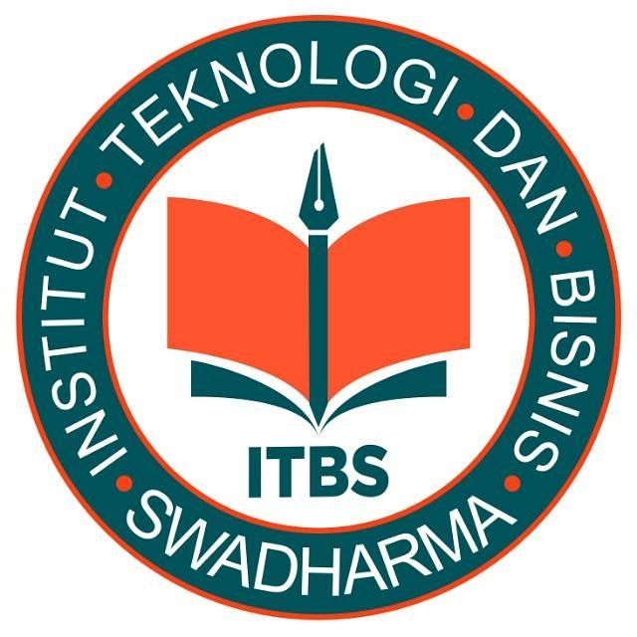 | INSTITUT TEKNOLOGI DAN BISNIS SWADHARMA | NOMOR DOKUMEN
 | JL. MALAKA No. 3 JAKARTA BARAT
Telp. (021) 691-5209, (021) 691-5210 Fax. (021) 691-5212
JL. PONDOK CABE RAYA No. 36 TANGERANG SELATAN
Telp. (021) 749-2432
 | Website : http//swadharma.ac.id

UJIAN TENGAH SEMESTER

SEMESTER GANJIL T.A 2021/2022

MATA KULIAH / sks : Bahasa Inggris
PROGRAM STUDI : Sistem Informasi / Teknologi Informasi
KELAS : KB01
JENJANG PENDIDIKAN : Strata Satu (S1)
HARI / TANGGAL : Senin, 22 November 2021
PUKUL : 13.00 – 14.30 WIB
DOSEN : V. Kun Marjonohadi, S.Sos., MM
SIFAT UJIAN : -

PETUNJUK UMUM
1. Jawaban dikumpulkan paling lambat 24 jam dari jadwal mulai pelaksanaan ujian
2. Jawaban ditulis tangan
3. Format jawaban
NAMA : TANDA TANGAN MAHASISWA
NIM :
TANGGAL :
PROGRAM STUDI :
KELAS :
MATA KULIAH :
DOSEN :
4. Tulis LEMBAR 1 / 2 / 3 / dst di ujung kanan atas tiap lembar jawaban
5. Kirim lembar jawaban dengan format pdf atau jpg/jpeg

Notes :
- Pray before doing the exam !
- .Write your Name and Student Id on your answer sheet !
- Do the easy number first !
- Check your answer sheet before submitting to SPADA

- Find the proper answer that fit to the following context by encircling A or B
- Programmer is people who (A : create, B : develop ) a computer program ( A ) ( B )
- Operating system is a tools to (A : activate, B : re-activate) computer ( A ) ( B )
- Data is usually stored to (A : hard disk, B : external hard drive) to save ( A ) ( B )
- Ring is one of the computer network (A : topology, B : typology) ( A ) ( B )
- Oracle is one of the computer (A : data script, B : database) ( A ) ( B )
- IT supports business by implementation of (A: e-business, B: e commerce) ( A ) ( B )
- IT Improvement makes the computer price (A. more expensive, B : cheaper) ( A ) ( B )
- Most small computers are in the form of (A. Laptop, B. Net book) ( A ) ( B )
- A lot of students conduct their business through (A. e-commerce; B. direct) ( A ) ( B )
- We could get a lot of information by surfing through (A: Google; B : Internet ( A ) ( B )

- Fill in the blank with the letter preceding words provided below
- We use computers for applications that were difficult to imagine 30 to 40 years ago. The usage of computers will have in the future are also hard …………………
- Electronic data processing and data processing are two terms which are really different; however they have now become synonymous and are used …………….
- Computers can be found in household …………such as air conditioner, home theatre etc
- Data processing involves the handling or …………….of facts and figures
- Some words associated with computer are not new, but are used almost ……….. in a computer related context.
- A software specialist reviews or ………. Software to see if it meets the needs of a particular company oar individual
- People with no experience or training must serve an …..….……to learn about computers and work in the field.
- The ……..……popularity of laptop and note book will ultimately result in decrease in the cost of these devices
- The rapid development of computer makes the device getting …………..
- Learning a new language, is ………….process, however, most people agree that this effort is worthy

Choice of words to answer :
( a ) appliance ( b) obsolete ( c ) evaluates ( d ) time consuming ( e ) interchangeably
( f ) apprenticeship ( g ) manipulation ( h ) increasing ( i ) exclusively ( j ) to envision

III. Fill in the blank with your owned suitable words or expression
- A place to store data to be processed temporarily inside the computer is ……………..…...
- We can store our data in an extra place called ………………… …….
- Computer can only perform what people instruct if there is ………..… inside it.
- The sequence of data processing cycle is …………………..
- Programming language that often be used in developing internet application is ………….
- Designer of the computer application program is …………………...…
- People who should join and accept the application during a system test is ………………..
- Integrated circuits are used in the …………………... computer generation
- Before integrated circuit, computer used ……………… technology in developing computer
- The future technology that has already been predicted by computer engineer is the implementation of ……………………. Technology.

IV. Fill in the blank with your owned suitable words or expression
- Computer is a programmable …………………to process data into output
- There are three main part or unit of the computer, in this case ……………………….. unit
- The data input of. the computer must be in the form of………………..data
- One of the implication of ‘very fast technology development is ……………….
- IT Organization might be developed as a ………………… functions
- Computer proses the data ……………………. and very fast.
- Activity to verify computer program that need to be implemented is conducted by …………..
- Programs that have already been tested and verified, could only be implemented if they have been approved by …………………………
- This approval of the program is usually conducted in the User ……………….Test
- After being implemented, the system have to be …………………… … during the period of post implementation review.

Good luck…

